Project: Loan management system

Admin > act as user

<https://trello.com/c/CWA4j8qC/11-c16-jul-21-22-comment>

|  |  |  |  |
| --- | --- | --- | --- |
| Date | Ver | By | Detail |
| Jul 21, 22 | 1 | CW | Comment q1 to q10 |
| Jul 26,22 | 2 | EL | Q4,7,8 test ok |
| Jul 27,22 | 3 | EL | Q2,Q3,Q6 test ok |
| Jul 30, 22 | 4 | CW | Hi eddie, pls check and demo to ivan too.  cw4.1 Q2/CW0730. I cannot see the values in Screen and DB. Pls tell me in QQ first.  cw4.2 Q3.2/Q3.3/not ok!!  Hi steve/roy,  How are Q1/Q5/Q9 |

Q1. Email put to db

Then use that template

Q2. 3 missing value to db

https://fullygreatasia.admatrix-ai.com/laravel3/public/individual/case

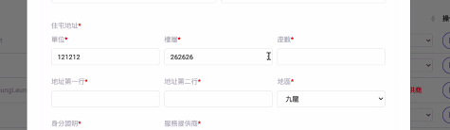

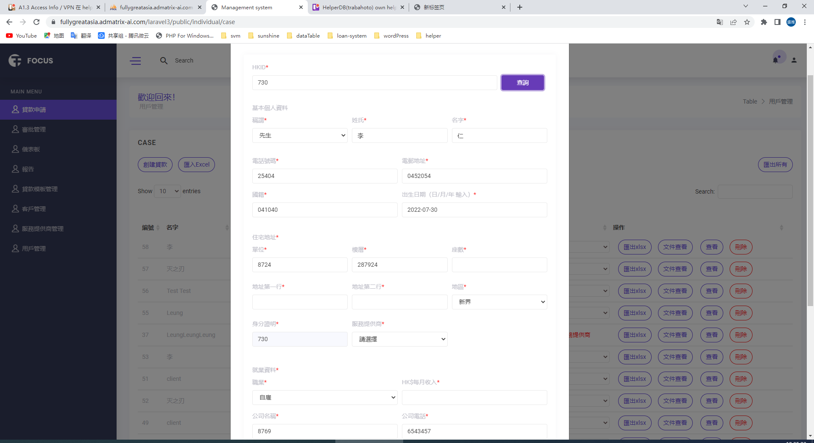

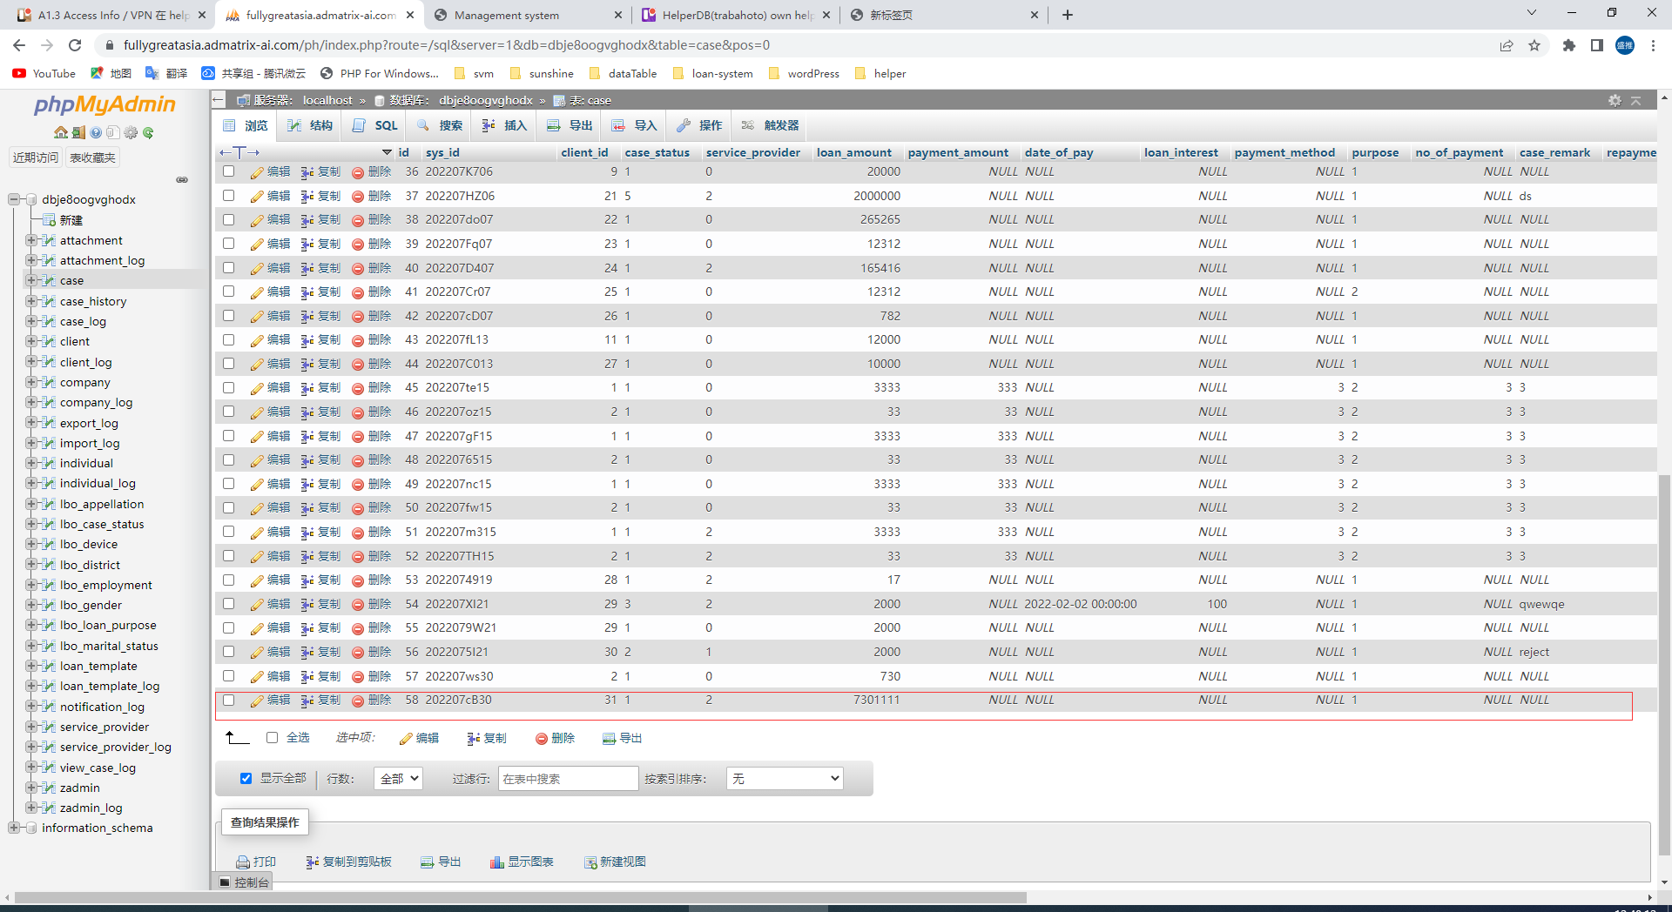

EL0730:test ok

Q2/CW0730. I cannot see the values in Screen and DB. Pls tell me in QQ first.

Q3 client upload problem

Q3.1 can see upload filename

Q3.2 rename filename, ccrm approach

Q3.3 add up to 5 files

https://fullygreatasia.admatrix-ai.com/laravel3/public/individual/case

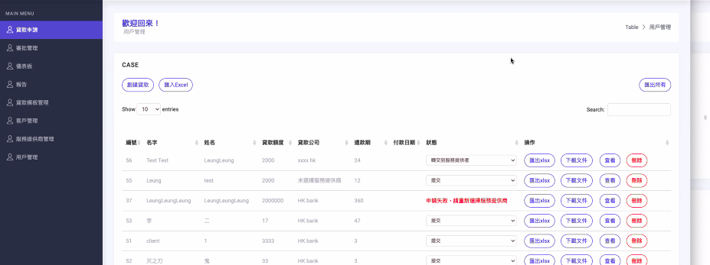

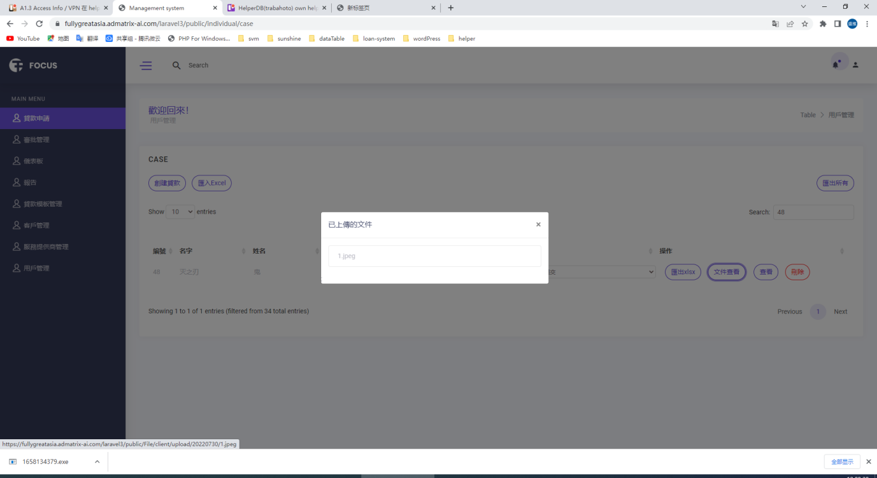

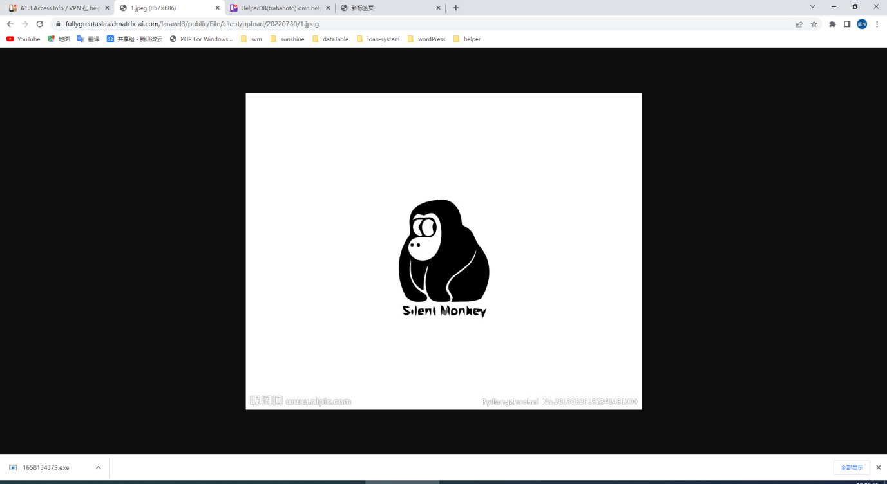

EL0730:test ok

Q4 change  not work sometimes

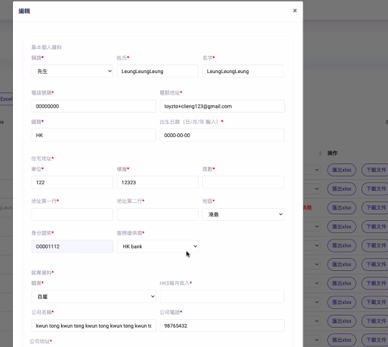

Q4 Test:

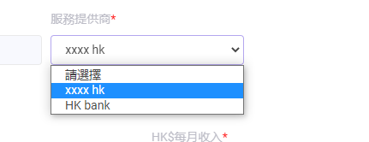EL 0726:test ok

Q5.

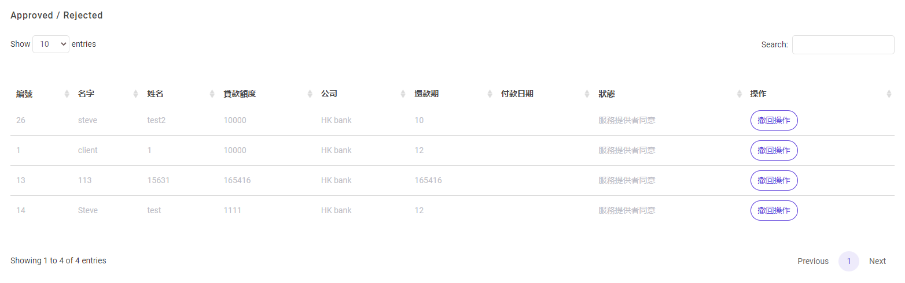

Q6.Dashboard

1. NO. of case in each SP

https://fullygreatasia.admatrix-ai.com/laravel3/public/individual/list

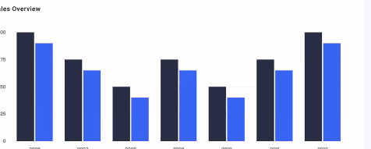

EL0729:fixed

1. Total no of case:

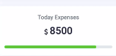

1. Total no. of person:

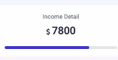

1. Total no. of SP(Active):

RM0728:fixed

1. Total no. of success case/reject case

12/100

6.

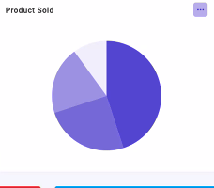

% of case of each SP

EL0729:fixed

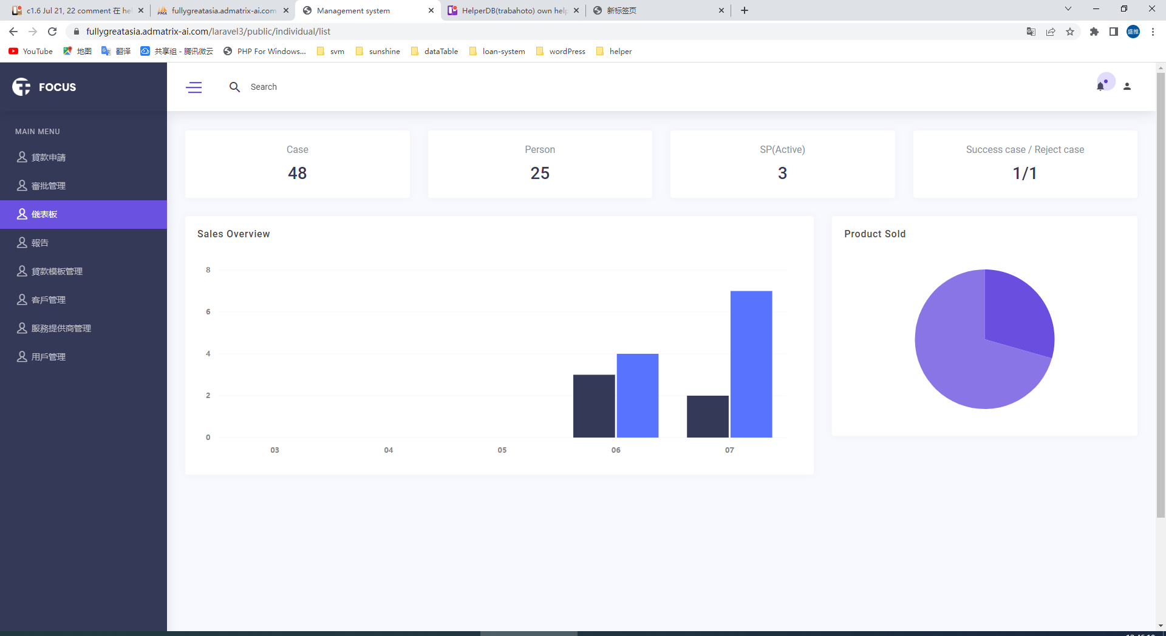

EL0730:test ok

1. Missing log
   1. admin log
   2. export
   3. view_case log
2. admin > missing ip/browser

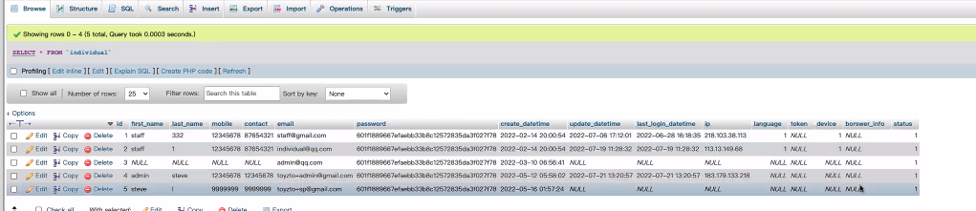

Test

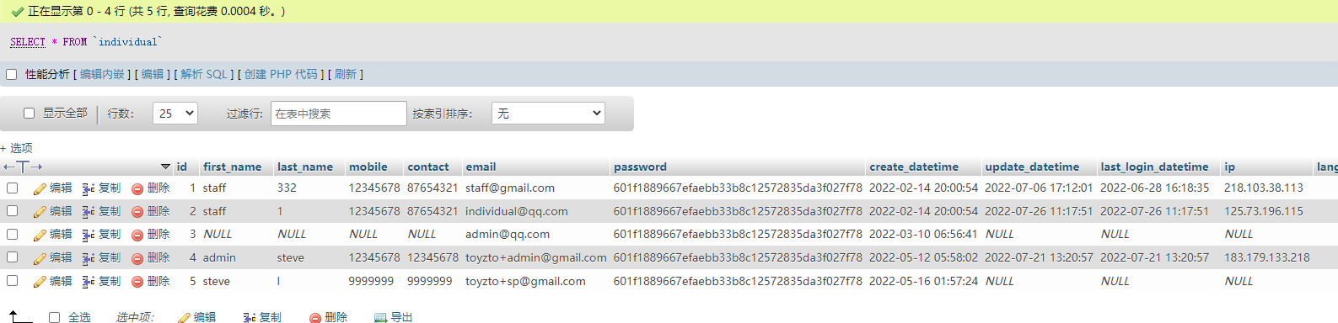EL0726:test ok

1. change table name admin to zadmin, admin_log > zadmin_log

Test:

EL0726:test ok;

1. update by is null? Missing browser in client and client_log, service_provider, service_provider_log

10 encryption: password is ok first